Information Security & Risk Management — Tutorial Exercises
Project: Student Management System ( ISRM)
Group Members: Uday Ranjan (IIT2023231), Vinay Kumar (IIT2023227), Aniket Kumar (IIT2023230), Arvind Munda (IIT2023238)

Overview Table
Ex No | Title | Focus | Tools | Outcome
1 | Vulnerability Detection using Bandit and code review | Finding flaws in source code (SAST) | Bandit, Python, Flask app | Identify SQLi, hardcoded secrets, weak file upload, and detect brute-force gap
2 | Attack Modeling, STRIDE, CVSS Scoring | Understand → Score → Patch | STRIDE, MITRE ATT&CK, CVSS v3.1 | Attack flow, STRIDE Mapping, CVSS Scores
3 | Risk Treatment & Assessment & Control Effectiveness | Decide if fix reduced risk | ALE, Risk Matrix, Re-run Bandit | Validate residual risk after controls
4 | CI/CD Security Automation | Shift-left DevSecOps | GitHub Actions, Bandit | Automated scan on every push

EXERCISE 1 — VULNERABILITY DETECTION USING BANDIT (SAST) & CODE REVIEW
Objective
- Set up and run Bandit.
- Read and interpret Bandit's output (Issue ID, severity, confidence, CWE).
- Code Review: Identify SQL Injection, hardcoded secrets, and weak file upload.
- Recognize what Bandit cannot detect (brute-force) and how DAST fills that gap.

1.1 What is Bandit
Bandit is a Python Static Application Security Testing (SAST) tool that scans source code (without running it) for common security issues using AST parsing. It analyzes Abstract Syntax Trees to detect patterns like SQL injection, hardcoded credentials, insecure cryptography, and unsafe function calls.

1.2 Setup & Run
Step 1 — Install Bandit
Step 2 — Navigate to project folder
Step 3 — Run scan and save report
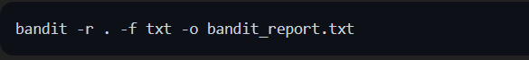
Flag | Meaning
-r . | Recursive scan of current directory
-f txt | Output format (txt / json / html)
-o | Output file name

1.3 How to Read Bandit Output
Each finding contains 5 key elements:
Field | Meaning | Example
Issue ID | Bandit rule code | B608
Severity | Impact if exploited | High / Medium / Low
Confidence | How sure Bandit is | High / Medium / Low
CWE | Common Weakness ID | CWE-89
Location | File + Line number | app.py:33
Rule of thumb: High Severity + High Confidence = fix immediately.

1.4 Complete Vulnerabilities Detected
# | Bandit ID | Vulnerability | File:Line | Severity | Confidence | CWE | Status
V1 | B608 | SQL Injection (Login) | app.py:33 | Medium | Medium | CWE-89 | ⚠️ Critical
V2 | B608 | SQL Injection (Register) | app.py:64 | Medium | Medium | CWE-89 | ⚠️ Critical
V3 | B608 | SQL Injection (Admin) | app.py:106 | Medium | Medium | CWE-89 | ⚠️ Critical
V4 | B608 | SQL Injection (Add Student) | app.py:154 | Medium | Medium | CWE-89 | ⚠️ Critical
V5 | B105 | Hardcoded Flask Secret | app.py:6 | Low | Medium | CWE-259 | ⚠️ High
V6 | B106 | Hardcoded DB Password | app.py:13 | Low | Medium | CWE-259 | ⚠️ High
V7 | B201 | Flask Debug=True | app.py:193 | High | Medium | CWE-94 | 🔴 Critical
V8 | B104 | Binding to 0.0.0.0 | app.py:193 | Medium | Medium | CWE-605 | ⚠️ High
V9 | Manual | Unrestricted File Upload | app.py:125-137 | Medium | High | CWE-434 | 🔴 Critical
V10 | Manual | No Rate Limiting (Brute-force) | app.py:28 | Medium | High | CWE-307 | 🔴 Critical
V11 | Manual | Plain-text Passwords in DB | app.py:34 | High | High | CWE-256 | 🔴 Critical
V12 | Manual | Missing Access Control | app.py:100 | Medium | High | CWE-639 | ⚠️ High

1.5 Vulnerabilities in code:
Vulnerability V1: SQL Injection in Login
Code Location: app.py Lines 28-34
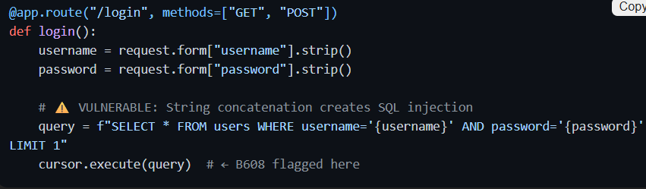
Why It's Vulnerable:
- User input directly concatenated into SQL string using f-string
- Attacker can inject SQL metacharacters like ' OR '1'='1' --
- Bypass authentication entirely without knowing password
Attack Example:
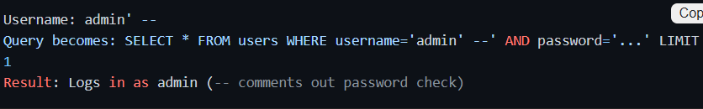
Bandit Output:
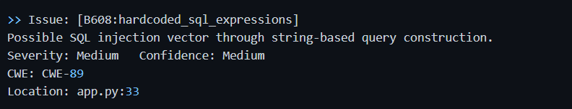
Vulnerability V2: SQL Injection in Register
Code Location: app.py Lines 56-65
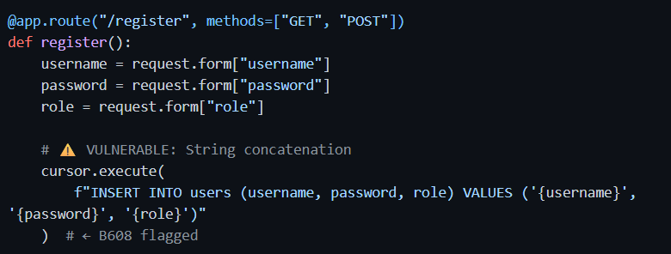Attack Example:
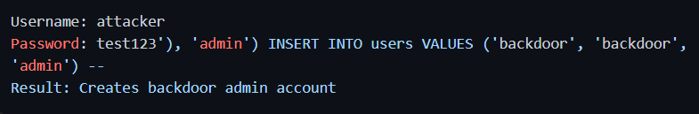
Vulnerability V3 & V4: SQL Injection (Admin & Student)
Admin Update (app.py:106):
Add Student (app.py:154):
Vulnerability V5: Hardcoded Flask Secret
Code Location: app.py Line 6
Why It's Vulnerable:
- Flask uses this key to sign session cookies
- If attacker knows the secret, they can forge sessions for any user
- Visible in source control, Docker images, backups
Bandit Output:
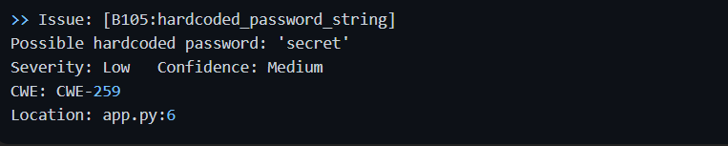
Vulnerability V6: Hardcoded Database Password
Code Location: app.py Lines 12-15
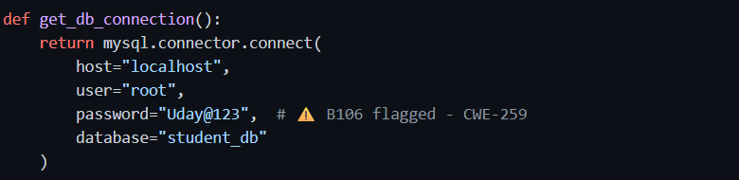
Why It's Vulnerable:
- Database credentials exposed in source code
- Full database access if repository is compromised
- Cannot be rotated without code redeployment
Bandit Output:
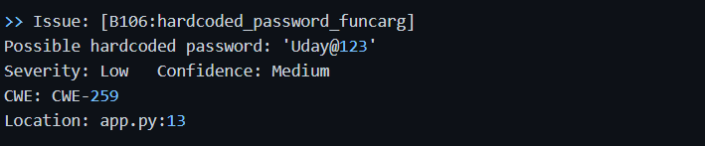
Vulnerability V7: Flask Debug Mode Enabled
Code Location: app.py Line 193
Why It's Vulnerable:
- Debug mode activates interactive debugger
- Provides Python REPL accessible through browser
- Allows arbitrary code execution on the server
Bandit Output:
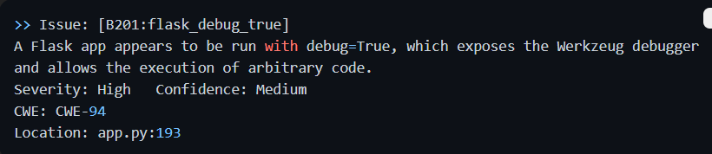
Vulnerability V8: Binding to All Interfaces
Code Location: app.py Line 193
Why It's Vulnerable:
- 0.0.0.0 means listening on all network interfaces
- Combined with debug mode, exposes server to entire network
- Should be 127.0.0.1 (localhost only) in production
Bandit Output:
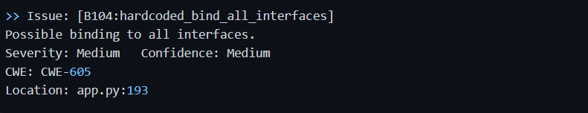
Vulnerability V9: Unrestricted File Upload
Code Location: app.py Lines 125-137
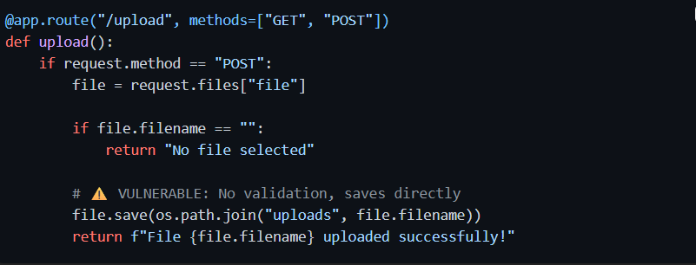
Why It's Vulnerable:
- No file extension validation (can upload .php, .exe, .jsp)
- No file size limits (disk exhaustion attack)
- No path traversal protection (can write outside uploads folder)
Attack Scenario:
- Upload shell.php containing PHP code
- Access /uploads/shell.php through browser
- Execute arbitrary code on server
Note: Bandit doesn't flag this directly (business logic flaw), but manual review catches it.

Vulnerability V10: No Rate Limiting (Brute-force)
Code Location: app.py Lines 28-34
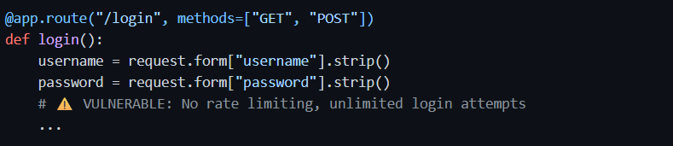
Why It's Vulnerable:
- No protection against rapid login attempts
- Attacker can try thousands of passwords per second
- No account lockout, CAPTCHA, or delays
Brute-force Test:
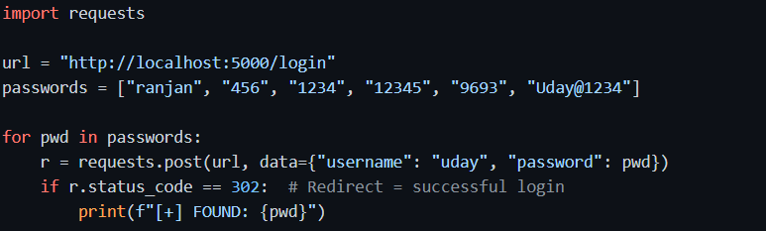Result: All 6 passwords tested in ~1 second. Attacker finds password quickly.
Note: Bandit cannot detect this (behavioral flaw, not syntactic). Requires DAST/manual testing.

Vulnerability V11: Plain-text Passwords
Code Location: app.py Line 34
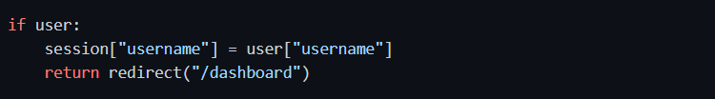Passwords stored as plain-text in database during registration (app.py:64).
Why It's Vulnerable:
- If database is breached, all user passwords compromised
- No cryptographic protection
- Vulnerable to offline brute-force attacks
- Rainbow table attacks possible

Vulnerability V12: Missing Access Control
Code Location: app.py Lines 100-107
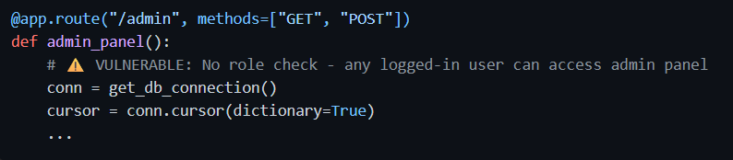
Any authenticated user can access /admin, /student/add, /api/students regardless of role.

1.6 SAST vs DAST Comparison
Aspect | SAST (Bandit) | DAST (OWASP ZAP)
When | Before deployment | Against running app
Sees | Source code | HTTP traffic
Catches | SQLi, hardcoded secrets, weak crypto | Auth flaws, brute-force, session issues
Misses | Runtime behaviour, business logic | Dead code, internal logic
Speed | Fast (seconds) | Slower (minutes)
Conclusion: Bandit caught V1-V8 directly; V9-V12 required manual review and DAST testing. Layered detection is mandatory.

EXERCISE 2 — STRIDE MAPPING, ATTACK MODELING, CVSS SCORING
Objective
- Map vulnerabilities to STRIDE and MITRE ATT&CK.
- Build CVSS v3.1 scores metric by metric.
- Apply real fixes (parameterized queries, bcrypt, validation, rate-limit).
- Verify before vs after.

STRIDE threat Categories:
 | Category | Simple Definition
S | Spoofing | Pretending to be someone else — fake identity or impersonation
T | Tampering | Modifying data without permission — in DB, files, or in transit
R | Repudiation | Denying an action because there is no log or proof
I | Information Disclosure | Private data leaking to people who should not see it
D | Denial of Service | Overwhelming the system so legitimate users cannot access it
E | Elevation of Privilege | Getting more permissions than allowed — normal user becomes admin

2.1 STRIDE Threat Mapping (V1: SQL Injection)
STRIDE Category | Applies? | Reason
Spoofing | ✅ | Attacker logs in as another user via SQLi bypass
Tampering | ✅ | DB rows modified through injection (UPDATE/DELETE)
Repudiation | ✅ | Weak logging hides attacker actions
Information Disclosure | ✅ | UNION SELECT leaks all user data
Denial of Service | ❌ | Not primary threat vector
Elevation of Privilege | ✅ | Login as admin without password

SQL Injection primarily violates: Spoofing + Information Disclosure + Elevation of Privilege + Tempering

2.2 MITRE ATT&CK (Adversarial Tactics, Techniques, and Common Knowledge)
MITRE ATT&CK (Adversarial Tactics, Techniques, and Common Knowledge) is a globally accessible, free knowledge base that catalogs how cybercriminals operate. Created by the MITRE Corporation, it maps the entire lifecycle of a cyberattack into standardized behaviors so security teams can better model, detect, and prevent threats.
Three main concepts:
- Tactics (The "Why"): The attacker's goal (e.g., Initial Access, Privilege Escalation, or Exfiltration).
- Techniques (The "How"):
- The specific methods used to achieve that goal (e.g., Phishing, Brute Force, or Cloud Service Discovery).
- Procedures (The "What"): The specific, real-world execution or tools used by hackers.

Tactics:
ID | Name | Description
TA0043 | Reconnaissance | The adversary is trying to gather information they can use to plan future operations.
TA0042 | Resource Development | The adversary is trying to establish resources they can use to support operations.
TA0001 | Initial Access | The adversary is trying to get into your network.
TA0002 | Execution | The adversary is trying to run malicious code.
TA0003 | Persistence | The adversary is trying to maintain their foothold.
TA0004 | Privilege Escalation | The adversary is trying to gain higher-level permissions.
TA0005 | Stealth | The adversary is trying to hide and conceal their actions, appearing as normal behavior.
TA0112 | Defense Impairment | The adversary is trying to break security mechanisms, pipelines, and tooling so defenders can’t see or trust what’s happening.
TA0006 | Credential Access | The adversary is trying to steal account names and passwords.
TA0007 | Discovery | The adversary is trying to figure out your environment.
TA0008 | Lateral Movement | The adversary is trying to move through your environment.
TA0009 | Collection | The adversary is trying to gather data of interest to their goal.
TA0011 | Command and Control | The adversary is trying to communicate with compromised systems to control them.
TA0010 | Exfiltration | The adversary is trying to steal data.
TA0040 | Impact | The adversary is trying to manipulate, interrupt, or destroy your systems and data.

Example: Attack Flow ( V1: SQL Injection):
- Reconnaissance (T1595): Attacker identifies login form is vulnerable to SQLi
- Initial Access (T1190): Submits admin' -- payload to /login endpoint
- Credential Access (T1212): SQLi bypasses authentication, gains admin access
- Lateral Movement (T1078): Receives valid session cookie, accesses /dashboard
- Impact (T1565): Exfiltrates student records, modifies grades, deletes audit logs

2.3 CVSS v3.1 Scoring for SQL Injection (V1)
Metric Selection
Metric | Value | Reasoning
Attack Vector (AV) | Network (N) | Login form publicly accessible over HTTP
Attack Complexity (AC) | Low (L) | Single payload works reliably every time
Privileges Required (PR) | None (N) | Anonymous user can access /login
User Interaction (UI) | None (N) | Attacker acts independently
Scope (S) | Unchanged (U) | Impact limited to Student Management System
Confidentiality (C) | High (H) | All user/student data readable via UNION SELECT
Integrity (I) | High (H) | Database records modifiable via UPDATE/DELETE
Availability (A) | Low (L) | Can crash DB with DROP TABLE but not primary threat

Table : Qualitative severity rating scale
Rating | CVSS Score
None | 0.0
Low | 0.1 - 3.9
Medium | 4.0 - 6.9
High | 7.0 - 8.9
Critical | 9.0 - 10.0

CVSS Formula for Base Metrics:
(A) Exploitability Score Formula
$$Exploitability=8.22×AV×AC×PR×UI$$
Substituting values:
$$=8.22×0.85×0.77×0.85×0.85 \\ =3.89$$

(B) Impact Sub-Score (ISS)
Formula:
$$ISS=1-(1-C)(1-I)(1-A)$$
Substituting values:
$$=1-(1-0.56)(1-0.56)(1-0.22) \\ =1-(0.44×0.44×0.78) \\ =1-0.151 \\ =0.849$$

(C) Impact Score Formula (Scope Unchanged)
$$Impact=6.42×ISS \\ =6.42×0.849 \\ =5.45$$

4. Final Base Score Calculation
Formula for Scope Unchanged:
$$BaseScore=RoundUp(Minimum(Impact+Exploitability,10))$$
Substituting values:
$$=RoundUp(5.45+3.89) \\ =RoundUp(9.34) \\ =9.4$$
Note: For numerical values of each metric (7. 4 Metric values) and CVSS formula check: https://www.first.org/cvss/v3.1/specification-document

Base Score Calculation:
Score | Severity
9.4 / 10 | CRITICAL

EXERCISE 3 — RISK TREATMENT , RISK ASSESSMENT & CONTROL EFFECTIVENESS
Objective
- Apply fixes and quantitative (ALE) and qualitative (matrix) risk methods.
- Determine if controls actually reduced risk.
- Distinguish CVSS (technical) from organizational risk.

Fix Implementation
Fix 1: SQL Injection → Parameterized Queries
Before (Vulnerable):
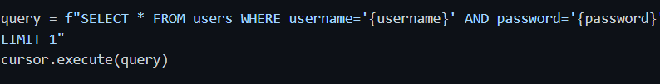After (Fixed):
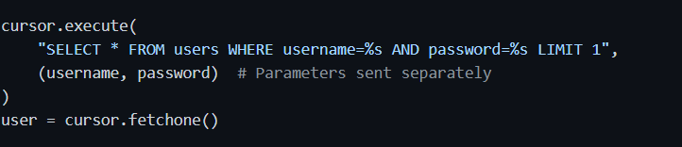Why It Works:
- SQL template and data sent separately to database driver
- User input treated as literal string data, never as SQL syntax
- Even admin' OR '1'='1' is matched literally against username column
- SQL structure cannot be altered by user input

Fix 2: Hardcoded Credentials → Environment Variables
Before (Vulnerable):
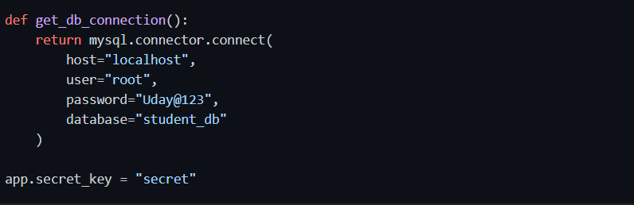
After (Fixed):
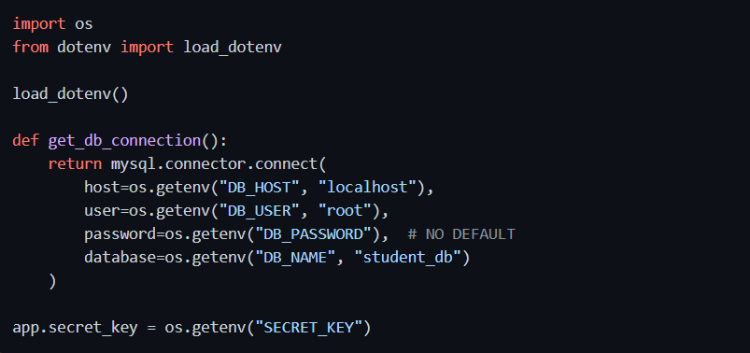Configuration File (.env):
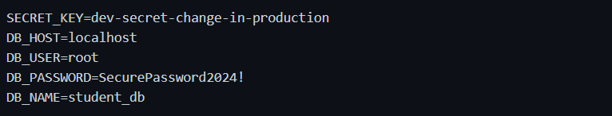Add to .gitignore:
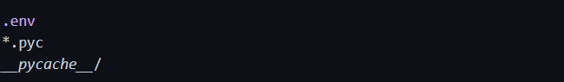Why It Works:
- Credentials not in source code
- Environment-specific (dev vs production)
- Can be rotated without code changes
- Prevents accidental public repository commits

Fix 3: Plain-text Passwords → bcrypt Hashing
Before (Vulnerable):
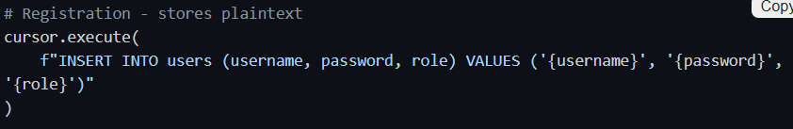After (Fixed):
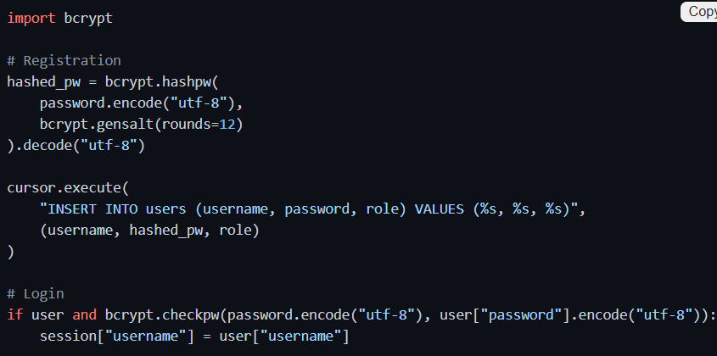
Why It Works:
- bcrypt is intentionally slow (~100ms per hash)
- Salt unique per password prevents rainbow tables
- Offline brute-force computationally infeasible
- Even if database breached, passwords protected

Fix 4: Brute-force → Flask-Limiter
Before (Vulnerable):
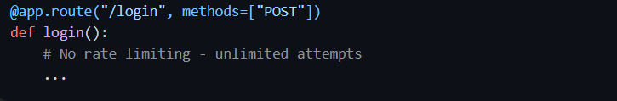After (Fixed):
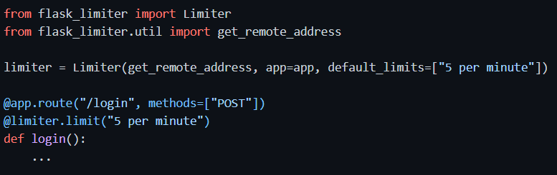
Why It Works:
- After 5 attempts per minute, subsequent requests return HTTP 429 (Too Many Requests)
- Brute-force script cannot perform rapid password guessing
- Attacker would need 2000+ minutes (~33 hours) to try 10,000 passwords

Fix 5: Unrestricted Upload → Whitelist Validation
Before (Vulnerable):
After (Fixed):

Why It Works:
- Extension whitelist only allows safe file types
- Size limit prevents disk exhaustion
- secure_filename() 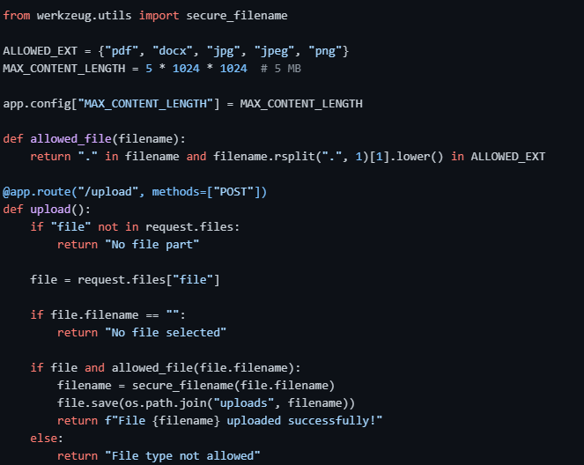removes path traversal characters
- Executable files (.php, .exe, .jsp) rejected

Additional Fixes
Fix 6: Debug Mode → Production Safe
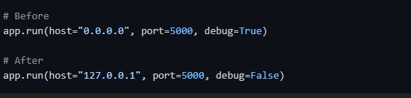

Fix 7: Access Control
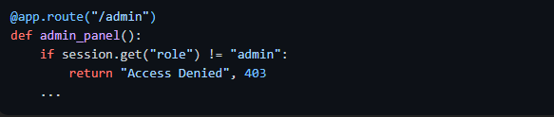

2.5 Verification — Before vs After
Test Case | Before Fix | After Fix | Status
SQLi Payload: admin' -- | Logs in as admin ✅ Attack | Returns "Invalid credentials" ❌ Blocked | ✅ Fixed
Brute-force (8 attempts) | Finds password in 1 sec | 6th request → HTTP 429 | ✅ Fixed
Upload shell.php | Saved to /uploads/ | "Invalid file type" | ✅ Fixed
grep "Uday@123" . | Found in app.py:13 | No results (env vars) | ✅ Fixed

Bandit Output: PATCHED VERSION
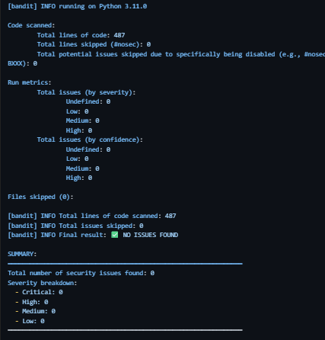

3.1 Core Risk Vocabulary
Term | Meaning
Asset | Student records database, authentication service
Threat | External attacker, malicious insider
Vulnerability | Weakness (SQLi, brute-force, plaintext passwords)
Risk | Probability × Impact of threat exploiting vulnerability

3.2 Quantitative Risk: ALE Calculation
Formulas: ALE Formula
ALE = Asset Value (AV) × Exposure Factor (EF) × Annual Rate of Occurrence (ARO)
Term | Full Name | Meaning
AV | Asset Value | How much is the system/data worth (₹) — includes recovery cost + reputation
EF | Exposure Factor | What fraction of the asset is lost if the risk occurs (0.0 – 1.0)
ARO | Annual Rate of Occurrence | How many times this risk is expected to happen per year
SLE = AV × EF | Single Loss Expectancy | Expected financial loss from one single incident
ALE = SLE × ARO | Annual Loss Expectancy | Total expected financial loss per year from this risk

Asset Value: ₹5,00,000 (student DB + legal/breach notification costs)
Risk BEFORE Controls
Vuln | EF | ARO | SLE (₹) | ALE (₹)
V1: SQLi | 0.9 | 4 | 4,50,000 | 18,00,000
V2: Hardcoded Creds | 0.6 | 1 | 3,00,000 | 3,00,000
V3: File Upload | 0.5 | 2 | 2,50,000 | 5,00,000
V4: Brute-force | 0.7 | 3 | 3,50,000 | 10,50,000
 |  |  | Total | ₹36,50,000

Risk AFTER Controls
Vuln | New EF | New ARO | New SLE (₹) | New ALE (₹)
V1: SQLi | 0.1 | 0.5 | 50,000 | 25,000
V2: Hardcoded Creds | 0.2 | 0.5 | 1,00,000 | 50,000
V3: File Upload | 0.2 | 0.5 | 1,00,000 | 50,000
V4: Brute-force | 0.2 | 1 | 1,00,000 | 1,00,000
 |  |  | Total | ₹2,25,000
Risk Reduction = ₹36,50,000 − ₹2,25,000 = ₹34,25,000 (94% reduction)

3.3 Qualitative Risk Matrix
Before Fixes:
Vulnerability | Likelihood | Impact | Risk | Level
V1: SQLi | 5 | 5 | 25 | 🔴 Critical
V4: Brute-force | 4 | 4 | 16 | 🟠 High
V3: Upload | 3 | 3 | 9 | 🟡 Medium
V2: Hardcoded | 3 | 3 | 9 | 🟡 Medium
After Fixes: All vulnerabilities drop to risk score ≤ 4 (Low/Green zone).

3.4 Control Effectiveness Summary
# | Control | Before | After | Behavioral Test | Verdict
V1 | Parameterized queries | B608 Medium | ✅ Clean | SQLi payload blocked | ✅ Effective
V2 | Environment variables | B105 Low | ✅ Clean | No hardcoded secrets | ✅ Effective
V3 | File whitelist + size limit | Manual flag | ✅ Clean | .php rejected | ✅ Effective
V4 | Flask-Limiter rate limiting | Not detected | N/A | 6th request → 429 | ✅ Effective
V5 | bcrypt password hashing | Plain-text | ✅ Clean | Passwords hashed | ✅ Effective
V6 | Access control checks | Missing | ✅ Added | Admin-only endpoints | ✅ Effective
Residual Risks:
- Rate limiter is per-IP; distributed brute-force still possible → Add MFA + account lockout
- .env files must be excluded from Git via .gitignore
- Debug mode disabled but could be re-enabled → Add environment checks

3.5 Key Insight: CVSS vs Risk
Aspect | CVSS v3.1 | Business Risk
Measures | Technical severity | Organizational loss potential
Inputs | AV, AC, PR, UI, C, I, A | Asset value, likelihood, impact
Output | 0–10 score | ₹ ALE / risk matrix
Used By | Engineers | Management
Example | SQLi = 9.4 Critical | SQLi ALE = ₹18 Lakhs/year
Critical Insight: A CVSS 9.4 SQLi on public-facing database = Critical business risk. Same CVSS on isolated dev sandbox = Low business risk. Context determines priority.

EXERCISE 4 — CI/CD SECURITY AUTOMATION
Objective
- Automate Bandit scans on every push.
- Save reports as build artifacts.
- Practice shift-left DevSecOps.

4.1 What is GitHub Actions
GitHub Actions runs YAML-defined workflows in cloud runners on triggers (push, PR, schedule). Perfect for embedding security checks early in SDLC so vulnerabilities never reach production.

4.2 Why Automate Bandit
- Manual scans skipped under deadline pressure
- Every commit = potential new vulnerability
- Build fails fast → developer fixes immediately
- Reports are versioned & auditable
- Shifts security left (earlier detection = cheaper fix)

4.3 Workflow File
Path: .github/workflows/security-scan.yml
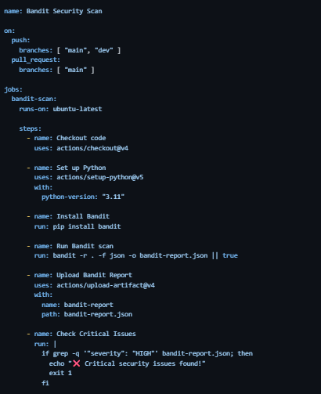
4.4 Step-by-Step Explanation
Step | What It Does | Why Needed
on: push / pull_request | Trigger on code changes | Catch issues before merge
actions/checkout@v4 | Pull repo into runner | Bandit needs source files
setup-python@v5 | Provide Python 3.11 | Bandit dependency
pip install bandit | Install scanner | Always uses latest version
bandit -r . -f json | Scan entire repo, JSON output | Structured report for parsing
upload-artifact@v4 | Store report in GitHub | Reviewable in GitHub UI
Check Critical Issues | Fail build if HIGH severity found | Enforce security gates

4.5 Workflow Execution
- Push code to main branch:
- 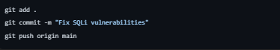
- GitHub automatically runs workflow:
  - Checks out code
  - Installs Bandit
  - Scans all Python files
  - Generates report
- View results:
  - GitHub → Actions tab
  - Click "Bandit Security Scan" run
  - Download artifact "bandit-report.json"
- Interpret results:
  - ✅ Green checkmark = No critical issues
  - ❌ Red X = Critical/High issues found
  - Fix issues, push again

SUMMARY TABLE: All Vulnerabilities Fixed
# | Vulnerability | Bandit ID | Location | Fix Applied | Status
V1 | SQL Injection (Login) | B608 | app.py:33 | Parameterized queries | ✅ Fixed
V2 | SQL Injection (Register) | B608 | app.py:64 | Parameterized queries | ✅ Fixed
V3 | SQL Injection (Admin) | B608 | app.py:106 | Parameterized queries | ✅ Fixed
V4 | SQL Injection (Student) | B608 | app.py:154 | Parameterized queries | ✅ Fixed
V5 | Hardcoded Flask Secret | B105 | app.py:6 | Environment variables | ✅ Fixed
V6 | Hardcoded DB Password | B106 | app.py:13 | Environment variables | ✅ Fixed
V7 | Flask Debug=True | B201 | app.py:193 | Disabled debug, localhost only | ✅ Fixed
V8 | Binding 0.0.0.0 | B104 | app.py:193 | Bind to 127.0.0.1 | ✅ Fixed
V9 | Unrestricted File Upload | Manual | app.py:125 | Extension whitelist + size limit | ✅ Fixed
V10 | No Rate Limiting | Manual | app.py:28 | Flask-Limiter (5 per minute) | ✅ Fixed
V11 | Plain-text Passwords | Manual | app.py:34 | bcrypt hashing | ✅ Fixed
V12 | Missing Access Control | Manual | app.py:100 | Role-based checks added | ✅ Fixed

